Sumário
Automação de Testes: *BPC = Bom Pra Crédito 1
Java/Selenium Webdriver. 1
//Classe para salvar printscreen 3
//Navigate 4
//TextBox 4
//ClickButton 5

Automação de Testes: *BPC = Bom Pra Crédito

Java/Selenium Webdriver.

https://demo.bompracredito.com.br/emprestimo-pessoal

- Planilha para controle de objetos:

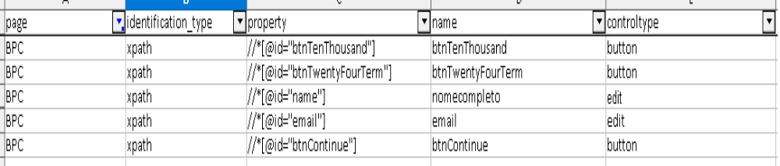

- Planilha para execução, contém links e massa:

aba Tests
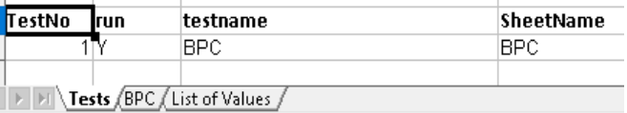
aba BPC
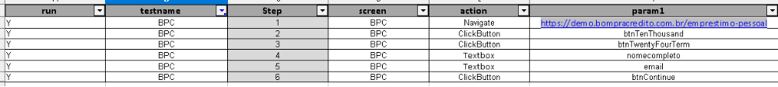
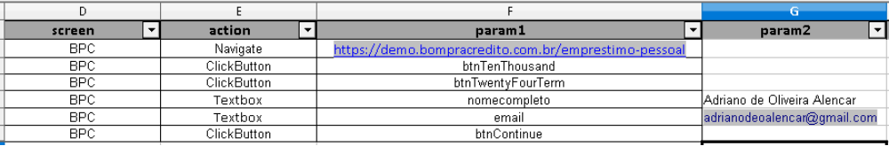
aba List of Values
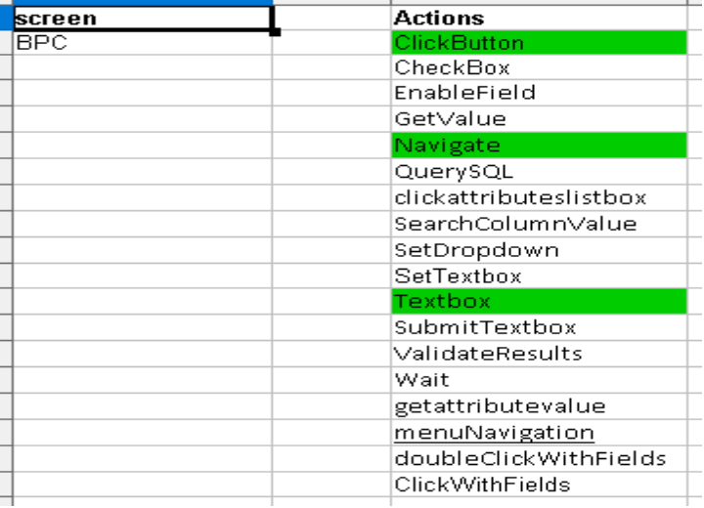

Mostrarei no trecho de código as 3 actions listadas em verde na imagem acima e uma classe para salvar o prinstcreen em um diretório:

package com.TestScripts.TestDriver;

import java.io.File;
import java.io.IOException;
import java.util.HashMap;

import org.apache.commons.io.FileUtils;
import org.junit.Before;
import org.junit.Test;
import org.openqa.selenium.OutputType;
import org.openqa.selenium.TakesScreenshot;

import com.gui_auto.base_classes.GUI_automation_properties;
import com.gui_auto.dao.DBmySQL;
import com.gui_auto.pages.BasePage;
import com.gui_auto.utilities.CompareDataInFile;
import com.relevantcodes.extentreports.LogStatus;

public class TestDriver extends Template_Test {

//Classe para salvar printscreen

public static void takeScreenShot(String fileName)
{

try
{
File src = ((TakesScreenshot)_driver).getScreenshotAs(OutputType.FILE);
FileUtils.copyFile(src, new File("D:\\Evidencias\\"+ fileName +".png"));
}
catch (IOException e)
{
e.printStackTrace();
}
}

protected static GUI_automation_properties _properties = new GUI_automation_properties();
private HashMap<Integer,HashMap<String,String>> testRun;
@Before
public void setUp() throws Exception {

super.setUp();
}

@Test
public void testBody() throws Exception {

boolean errorFound = false;

String query1 = "select * from Tests where run = 'Y'" ;

testRun = queryExcel(_properties.getProperty(GUI_automation_properties.XLS_DATA), query1);

for (int testCount = 0;testCount < testRun.size();testCount ++ ){

String query = "Select * from " + testRun.get(testCount).get("SheetName") + " where run = 'Y' and testname like '" + testRun.get(testCount).get("testname")+"'";
HashMap<Integer,HashMap<String,String>> testSteps = queryExcel(_properties.getProperty(GUI_automation_properties.XLS_DATA), query);

test = extent.startTest(testRun.get(testCount).get("testname"));

System.out.println(testRun.get(testCount).get("testname"));

for(int steps = 0;steps < testSteps.size();steps++){

if (testSteps.get(steps).get("testname").equals(testRun.get(testCount).get("testname"))){

String pageIdentification = testSteps.get(steps).get("screen").toLowerCase();
BasePage myPage = new BasePage(_driver, pageIdentification);
System.out.println(testSteps.get(steps).get("testname") + " [" + testSteps.get(steps).get("Step") + "]: " + testSteps.get(steps).get("action"));

switch(testSteps.get(steps).get("action").toLowerCase()) {

//Navigate
case "navigate":
try
{
myPage.navigateToPageAndWait(testSteps.get(steps).get("param1"));
test.log(LogStatus.PASS, "Step (" + testSteps.get(steps).get("Step") + ") - Page successfully opened");
takeScreenShot("Step (" + testSteps.get(steps).get("Step") + ")");
}
catch (Exception ex)
{
test.log(LogStatus.FAIL, "Step (" + testSteps.get(steps).get("Step") + ") - Unable to navigate to page.\n" + ex.getMessage());
errorFound = true;
}
break;

//TextBox

case "textbox":
try
{
myPage.textbox(testSteps.get(steps).get("param1"), testSteps.get(steps).get("param2"), testSteps.get(steps).get("param3"));
test.log(LogStatus.PASS, "Step (" + testSteps.get(steps).get("Step") + ") - Textbox fulfilled");
takeScreenShot("Step (" + testSteps.get(steps).get("Step") + ")");
}
catch(Exception ex)
{
test.log(LogStatus.FAIL, "Step (" + testSteps.get(steps).get("Step") + ") - Unable to fulfill textbox.\n" + ex.getMessage());
errorFound = true;
takeScreenShot("Step (" + testSteps.get(steps).get("Step") + ")");
}
break;

//ClickButton
case "clickbutton":
try
{
myPage.ClickButton(testSteps.get(steps).get("param1"));
test.log(LogStatus.PASS, "Step (" + testSteps.get(steps).get("Step") + ") - Button clicked");
takeScreenShot("Step (" + testSteps.get(steps).get("Step") + ")");
}
catch (Exception ex)
{
test.log(LogStatus.FAIL, "Step (" + testSteps.get(steps).get("Step") + ") - Unable to click on button.\n" + ex.getMessage());
errorFound = true;
}
break;

- Obs.: Seguindo com a automação: Os CPF's para testes seriam gerados no site https://www.4devs.com.br/gerador_de_cpf e populados na planilha de execução. Para geração de massas existem alguns sites na internet que geram nomes e dados para testes, cito https://pt.fakenamegenerator.com/

